21.72: a) Free body diagram as in 21.71. Each charge still feels equal and opposite electric forces.
b) (Note: 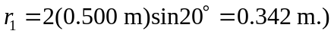
c) From part (b), 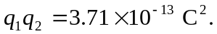
d) The charges on the spheres are made equal by connecting them with a wire, but we still have 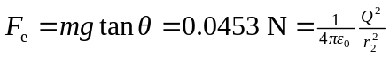where 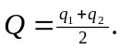 But the separation 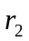is known: 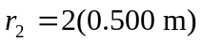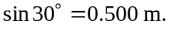Hence: 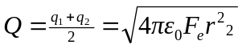 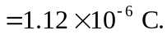 This equation, along with that from part (b), gives us two equations in 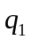and 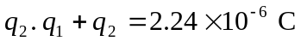and 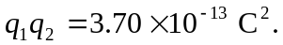By elimination, substitution and after solving the resulting quadratic equation, we find: 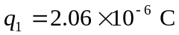and 

